RESPONSIBLE AI PART ¾

EU RULES AND GUIDELINES TO AI

1. EU Ethics guidelines for Thrustworthy AI

* **Lawful**
* **Ethical**
* **Robust**

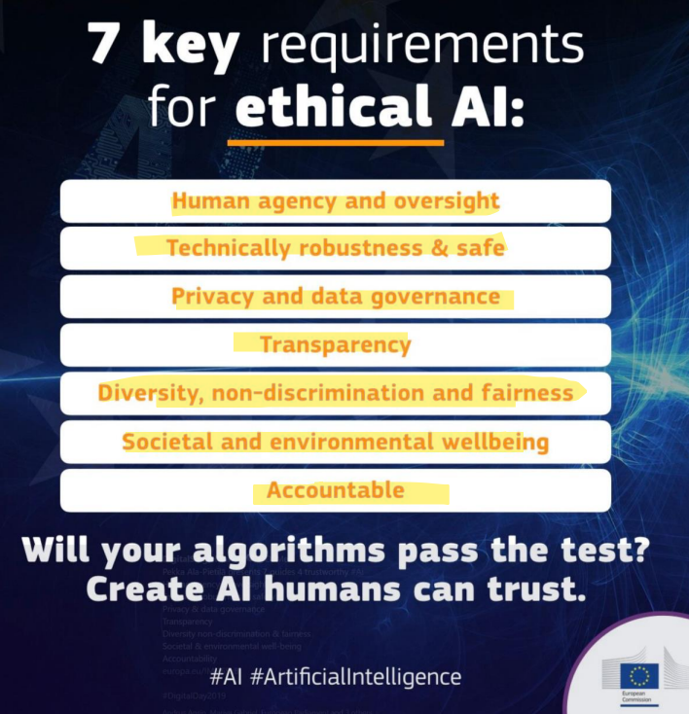

1. Human Agency and oversight

* Like many technologies, AI systems can equally enable and hamper fundamental rights. Oversight may be achieved through governance mechanisms, preventing that. Humans should be given the knowledge and tools to comprehend and interact with AI systems to a satisfactory degree and, where possible, be enabled to reasonably self-assess or challenge the system.

1. Technical robustness & safety

* AI systems, like all software systems, should be protected against vulnerabilities that can allow them to be exploited by hacking. Back-ups of the AI systems are necessary. Also, in terms of robustness, accuracy pertains to an AI system’s ability to make correct judgements

1. Privacy and data governance

* AI systems must guarantee privacy and data protection throughout a system’s entire lifecycle. In any given organization that handles individuals’ data, protocols governing data access should be put in place. The quality of the data sets used is paramount to the performance of AI systems, Biases, info corruption and errors must be taken into account.

1. Transparency

* The data sets and the processes that yield the AI system’s decision, should be documented to the best possible standard. Also, AI systems should not represent themselves as humans to users.

1. Diversity, non-discrimination and fairness

* Identifiable and discriminatory bias should be removed in the collection phase where possible. Particularly in business-to-consumer domains, systems should be user-centric and be able to be used by anybody, regardless of demographic.

1. Societal and environmental wellbeing

* Research should be fostered into AI solutions addressing areas of global concern, such as the Sustainable Development Goals
* The use of AI systems should be given careful consideration particularly in situations relating to the democratic process, including not only political decision-making but also electoral contexts

1. Accountability

* Evaluation by internal and external auditors, and the availability of such evaluation reports, can contribute to the trustworthiness of AI